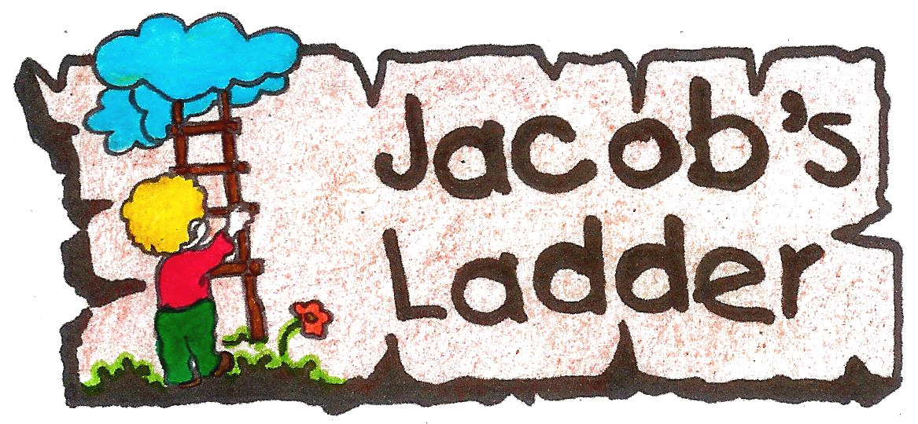

October 2024
JACOB’S LADDER FEE STRUCTURE FOR 2025

TUITION FEES
Preschool fees are payable in advance over 11 months, quarterly or annually. A monthly statement will be provided via e-mail, or in hard copy if required.
Fee statements are sent via e-mail at the beginning of the month for the month to follow – i.e., beginning of January for January fees to be paid in January.

 | 3-to-4-year group  Butterflies | 4-to-5-year group  Ladybugs | Grade R group  Busy Bees
Monthly Fees | R3,966.00 x 11 | R3,96600 x 11 | R4112.80 x 11
Termly Fees | R10,907.00 x 4 | R10,907.00 x 4 | R10,670.00 x 4
Annual Fees paid by 31 January receive R1,200 discount | R43,956  -R1,200.00  =R42,756 | R43,956  -R1,200.00  =R42,756 | R45,232  - R1,200.00  =R44,032

AFTERCARE FEES
Monthly aftercare fees are payable in advance over 10 months. Casual aftercare fees are charged in arrears. Aftercare fees will be added to the monthly school fee statement.

Monthly (3 to 5 times a week, every week): Casual (1 or 2 days a week):
Collect between 12:45 and 15:30: R1,060.00 x 10 R85 per day
Collect between 15:30 and 17:30: R1,325.00x 10 R116 per day

ADMIN FEE: R400
A non-refundable admin fee will be charged on application per child and needs to accompany the completed application form. Payment of the admin fee does not guarantee acceptance.

ACCEPTANCE FEE: R2,500
A non-refundable acceptance fee will be charged on placement of each child at Jacob’s Ladder Preschool.
This fee will be allocated by the principal towards administration, school development costs, teaching resources, and equipment.

STATIONERY, T-SHIRT & OUTING PROVISION:
We endeavour to keep costs as low as possible. Additional payments may be required for things like the school t-shirt and hat and outings requiring payment. Requests may be made during the year for donation of specific items required in the classroom.

PLEASE NOTE THE FOLLOWING ADDITIONS: - THE SMALL PRINT!
- Force Majeure – No fee waivers, refunds, or discounts on school fees for periods of remote learning will be granted.
  - Every effort will be made to ensure the full curriculum is covered, even if by remote learning.
  - Within reason and where possible school days missed will be made up during the year: five days of remote learning equates to three school days.

Fees and additions for 2025 have been set and approved by the Parent Finance Committee and Principal.

